**Progress Report of this week:**

In this week, we worked on implementing Apriori Algorithm on the pre-processed data set and successfully completed it. Following picture shows the output generated after implementing the Algorithm.

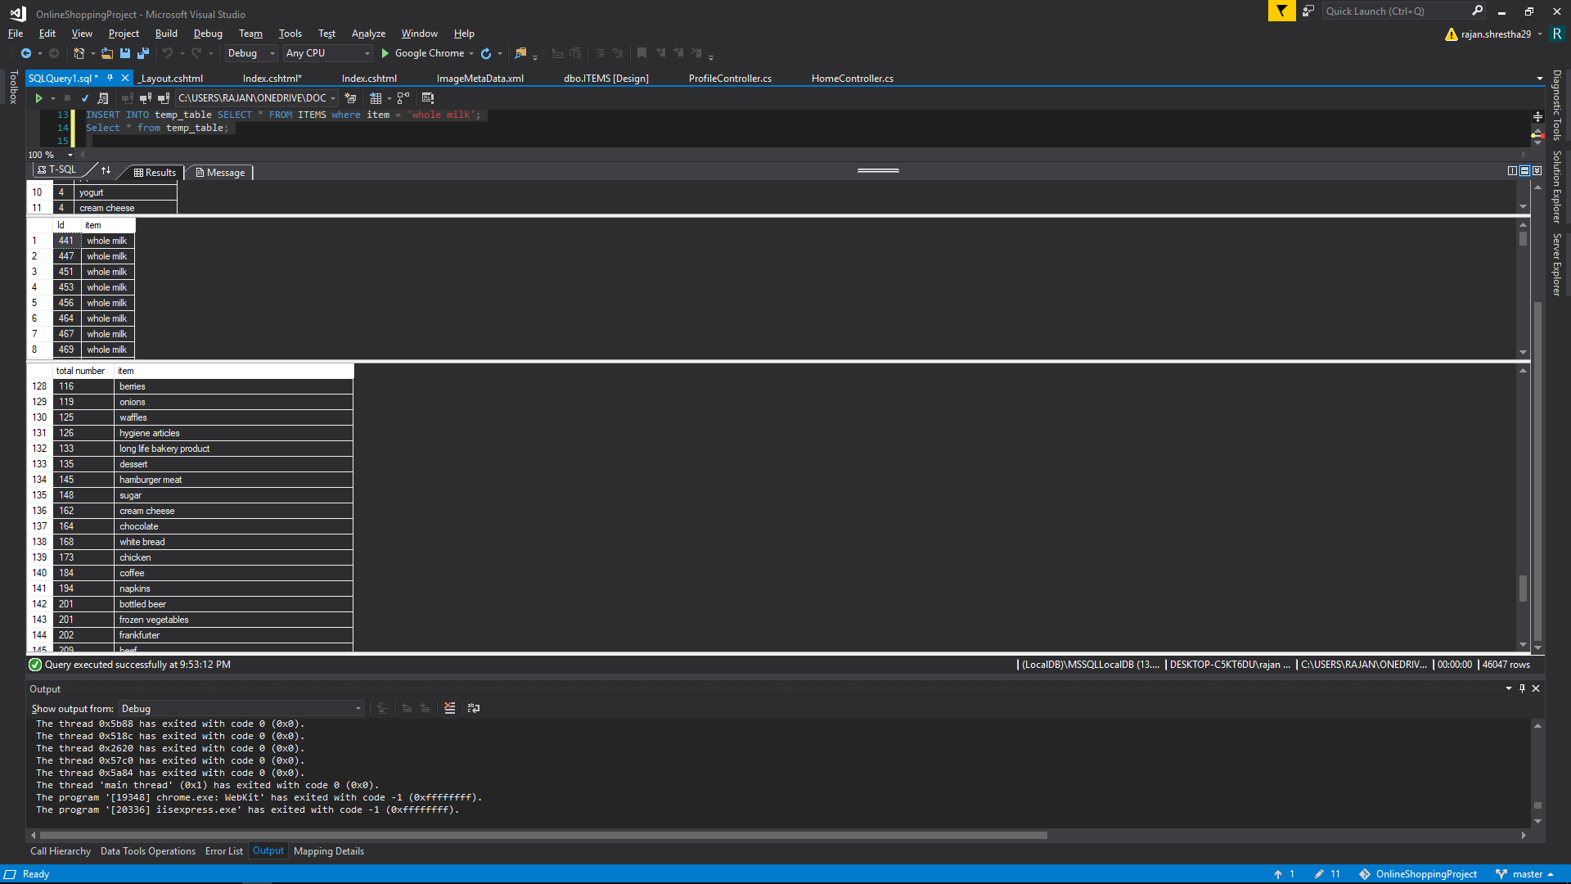

Here, whole milk is the item selected for which recommendation is to be obtained. Using the Apriori algorithm, we obtained all the transactions where the whole milk has appeared. The second table shows the Id of each transaction where whole milk is purchased. The third table shows the number of occurrences of each of the items with whole milk among all transactions. Since, “other vegetables” has the highest frequency i.e. 736 as compared to other items, it will be the recommendation for whole milk.

For next week:

We are still working on optimizing the confidence, in case we are not able to get proper recommendation.

Furthermore, we will be working on binding database with UI to select particular item and get proper recommendation from back end.

Baldev Bhattarai

Denish Kayastha

Rajan Shrestha